

Lotusphere 2011

IBM Collaboration Solutions Development Lab

Lab 2

Creating and deploying a Java plugin for Notes and Symphony

Part 1: Create a Live Text Recognizer

Introduction
Widgets and Live Text enable end users to see and act on Live Text in a document, including mail, using widgets created for their use. For example, a user can see a specially highlighted Live Text string (such as a customer number) and instantly act on it (for example, look up a customer status) by opening a customer status widget that is linked to that Live Text. Widgets and Live Text also enable power users and administrators to create and edit widgets.

Objective
This lab will explain the following tasks:
- Create a Content Type
- Create a Recognizer associated to the Content Type
- Configure a Widget from Notes to perform a full text search on a view

Upon completion of this lab, you will be able to create, edit and use Widgets and Live Text

Procedure

Step 1: Launch Lotus Notes and and find the My Widgets Sidebar Panel
a) Launch Lotus Notes (using the password 'passw0rd')

b) The My Widgets panel will be visible in the sidebar

Note: If not visible , check the Widgets Preference setting or View menu to show the My Widgets panel

Step 2: Configure a Content Type

a) From the My Widgets Panel, select Configure a Content Type

b) Provide a descriptive name

c) Add a new property for number because our company number contains both a unique set of characters to make it easy to recognize as well as the unique identifier

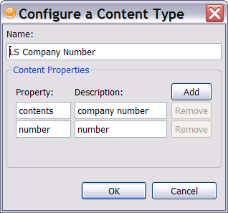

Step 3: Configure a Recognizer
a) From the My Widgets Panel, select Configure a Recognizer

b) Provide a descriptive name and select the Content Type

c) Enter a regular expression. In the example below
    - “ACT” is the unique set of characters to find the company number.

    - “(\d{4})“ specifies a company number must have 4 digits.

- Add a grouping for the unique company identifier. Group 0 is the entire contents and each additional group is used to parse the recognized text.

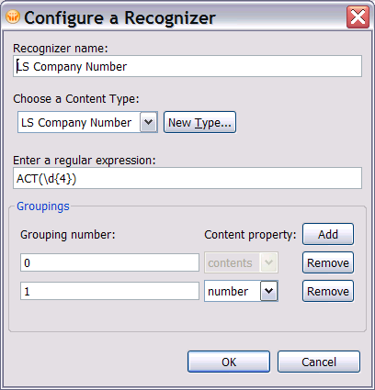

Step 4: Configure a widget from a Notes View

a) Open the Lead Manager Core NSF (in the 'lmca' directory) and View, Prospects By Company

b) Select a row in the view and press the action bar icon to Configure a

Widget from the Current Context...

c) Select “Perform a full text search on this Notes view” and press Finish. This will add a Widget to the My Widgets Sidebar panel.
d) Use the Right Mouse in My Widgets to configure a new action

e) On the Basics Tab, select the recognizer and information which will be passed to the widget:
    - LS Company Number Recognizer
    - Content type property is number
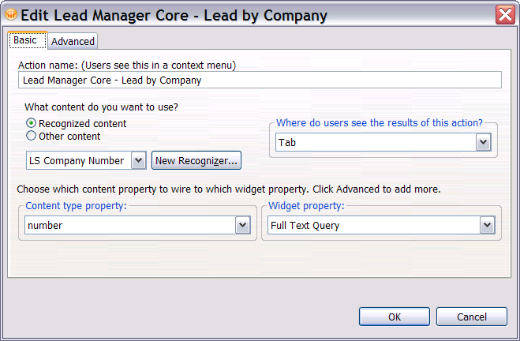

Step 5: Test the Live Text and Widget

a) Open the Lab Discussion NSF and open the first document. The text which is recognized will be underlined in blue (note, this may take a moment to initialize). Use the right mouse menu to view options or left mouse to launch the default widget.

Select Display LS Company Number Properties to inspect the Content Type

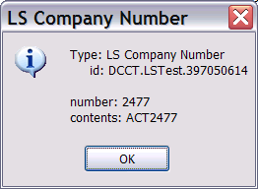

Summary:
In this lab you learned how to Create a Content Type, Recognizer and Widget for Notes without writing any code. Many documents and emails contain recognizable text which have deterministic actions. You can now make these documents live by associating the text, parsing when appropriate and then initiating an action with a single click.

References:
Lotus Notes and Domino wiki
Using Live Text and Widgets to improve productivity of daily work

