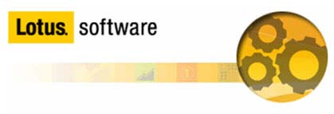

Lotusphere 2011

Lotus Solutions Development Lab

Lab #2

Part 5: Installing using a Widget

Introduction
One of the simplest methods for a user to install a plugin into Notes is to use a Widget. By hosting an NSF-based update site on a Domino server, an administrator can allow users to simply drag and drop a widget to their My Widgets sidebar in Notes, to automatically install a Java plugin. This lab will show how an application developer, and and administrator can team up to provide another server-managed method of distributing plugins.

Objective
In this lab, you will:
    - Learn how to create a policy and widget catalog on a Domino server
    - Create an NSF-based update site to host the Eclipse update site for your feature/plugin
    - Learn how to construct a deployment widget
    - Deploy the widget and use it to install the feature/plugin

This lab should take approximately 15 minutes to complete.

Procedure

Step 1: Creating the Widget Catalog and Desktop Policy

a) The first step is to launch the Domino server using the 'Lotus Domino Server' icon on the desktop: 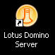

b) When the server has completely started, launch the Domino Administrator client using the 'Domino Admin 8.5' icon on the desktop: 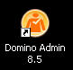.

c) After the Administrator client has started, ensure it is connected to the server 'Lab2/SolutionsDevelopmentLab', and select the 'Files' tab. Then use the
'File->Application->New...' menu option to create a new Application.

d) In the top half of the 'New Application' dialog, set the 'Server' field to Lab2/SolutionsDevelopmentLab. Next, set the title to something descriptive. I chose Solutions Development Lab Widget Catalog. Next, set the 'File name' field to Widgets.nsf

e) In the bottom half of the 'New Application' dialog, set the 'Server' field to Lab2/SolutionsDevelopmentLab. Next, select the 'Show Advanced Templates' checkbox, and choose Widget Catalog (8.5) from the 'Template' field. See figure 1 for an example. Click the 'OK' button to create the database.

Figure 1: Creating the Widget Catalog
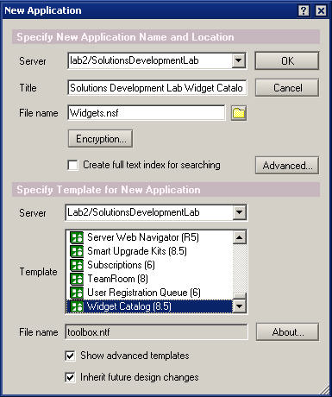

After the catalog is created, it should be open in the Administrator client.

f) Open the 'File->Application->Access Control...' menu and make sure the Admin Lab2/SolutionsDevelopmentLab user as the 'Admins' role selected. See figure 2.

Figure 2: Admins role
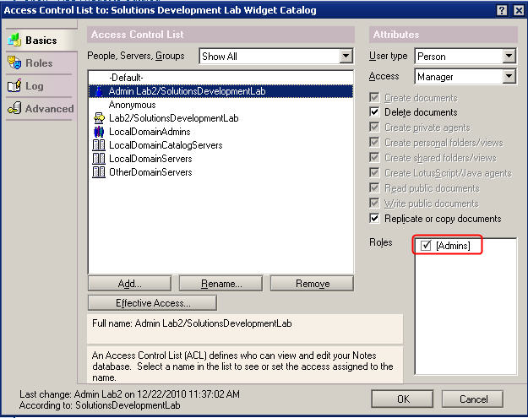

g) Click 'OK' to save it.

Now, we will leave the Widget Catalog for a bit, and go on to creating the Desktop Policy to allow users to deploy via a widget. While still in the Administrator client:

h) Navigate to the 'Configuration' tab, and open the 'Policies->by Settings' view. Select the 'Create...' action in the Policies toolbar on the right. In the 'Create New Policy' dialog, select the 'Settings' radio button, and choose 'Dynamic Desktop' as the type. See Figure 3.

Figure 3: Create a new Desktop Settings policy
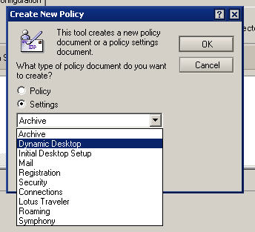

i) On the 'Basics' tab, give the policy a name, for example 'Widget Settings', then navigate to the 'Widgets' tab.

j) In the 'Widget catalog server' field, enter 'Lab2/SolutionsDevelopmentLab' (the current server). Also change the 'How to apply this setting' drop-down to 'Set value whenever modified'.

k) On the 'Widget catalog application name' field, change this to the name of the Widget Catalog you created earlier, Widgets.nsf, in the example we used. Also change the How to apply this setting' drop-down to 'Set value whenever modified'.

l) Set the 'Show the My Widgets panel in the sidebar' field to 'Yes', and change the 'How to apply this setting' drop-down to 'Set value whenever modified'.

Note: You can click and hold each of the field names to get a description of what it is for.

m) Click the 'Save and Close' button at the top.

Once you have the Desktop Settings document created to specify the Widgets settings, it is time to create the Desktop Policy to apply those settings to specific users. To do so:

n) Select the 'Create...' button on the 'Tools->Policies' sidebar in the Administrator client again. This time, choose to create a 'Policy' and click 'OK'.

o) Once the 'New Policy' document opens, give the Policy a name: Desktop Policy for Widgets on the 'Basics' tab, and under the Desktop Setting Type, use the combo box drop down to select the 'Widget Settings' document we created earlier.

p) On the 'Policy Assignment' tab, either enter manually, or use the name selector to enter 'Admin Lab2/SolutionsDevelopmentLab' into the 'Users and Groups' field. This isn't mandatory, but will ensure that the policy gets pushed down correctly when we authenticate with the Notes client later.

q) Click Save and Close to save the new policy.

Step 2: Creating the NSF-based Update Site

a) Navigate back to the 'Files' tab, and select 'File->Application->New...'. In the New Application dialog, make sure both 'Server' fields are 'Lab2/SolutionsDevelopmentLab', and give the application a title and file name. Select the 'Advanced Templates' check box, and highlight the 'Eclipse Update Site (8.5) template to base this application on. See Figure 4 for an example. Click 'OK' to create the application.

Figure 4: New Application – Update Site
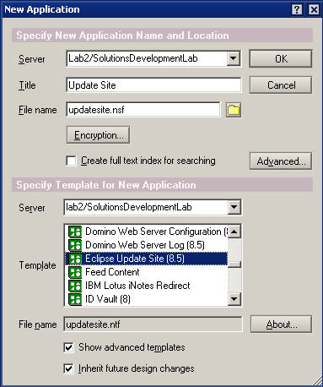

b) Once the application is created and open, you can import the Eclipse update site for the plugin into the new application. To do so, click the 'Features' view on the left, and then click the 'Import Local Update Site' button.

Note: If you have not done so already, please use the Windows Explorer to extract c:\plugin_lab2.zip to a folder called 'plugin_lab2', or you can use the Update Site you exported in part 2 of this Lab.

c) Using the 'Import Local Update Site' wizard, browse to either Update Site (plugin_lab2, or your own), and select the site.xml. Click 'OK'.

For a few moments, you will see the Update Sites features and plugins (jar files) get imported, and should see a message saying the import succeeded. You should see the 'Lotusphere Feature' now listed in the Features view.

d) Once the application is created, please close the Administrator client.

Step 3: Creating the Widget to use to deploy the plugin

There are a number of ways to create a widget's extension.xml file that will instruct the client on how to install your custom plugin. You could create it by hand, modify a sample (such as the one found on the Lotus Support website in the document: How to use a Notes widget to deploy a new plug-in to an existing Notes installation), or you can simply use the Wizard that comes with the Notes client. That is the method we will use.

a) Launch the Lotus Notes client using the 'Lotus Notes 8.5' icon on the desktop: 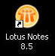

b) After entering the password and the client has started, establish a session with the Domino server by using 'File->Open->Lotus Notes Application' (or CTRL+O) and entering 'Lab2/SolutionsDevelopmentLab' in the 'Look in' field, and click the 'Open' button.
Once the session with the server is established, the Policy we created in the last section will get pushed to the client, and your Widgets preferences will be updated. Select the 'Update Site' (updatesite.nsf) from the list of applications, and click 'Open' again to open the Update Site we created in the last step. When the application is open, select the 'Actions->Show URLs...' menu item, and copy the 'nrpc://' link to the clipboard. We will use this to create the Widget in a few moments.

Note: You can use the 'http://' link provided, but you will need to load the HTTP task on the Domino server in order to use this method.

c) Close the Update Site.

d) Next, select the 'Tools->Widgets->Getting Started with Widgets...' menu. This will launch the wizard to help configure a new Feature and Plugin widget. Read the helpful text on the first page of the wizard, select the 'Features and Plugins' radio button, and click 'Next'.

e) Paste the NRPC URL you copied into the URL field at the top of the 'Configure a Widget from an Update Site' dialog. Then click the 'Load' button. This should make a call to the Domino server to look up the site.xml you specified, and pull the information about the Feature listed in the update site. Once the 'com.ibm.lotusphere.feature' is found, select the check box next to it and click 'Next'. See Figure 5.

Figure 5: Configure a Widget from an Update Site
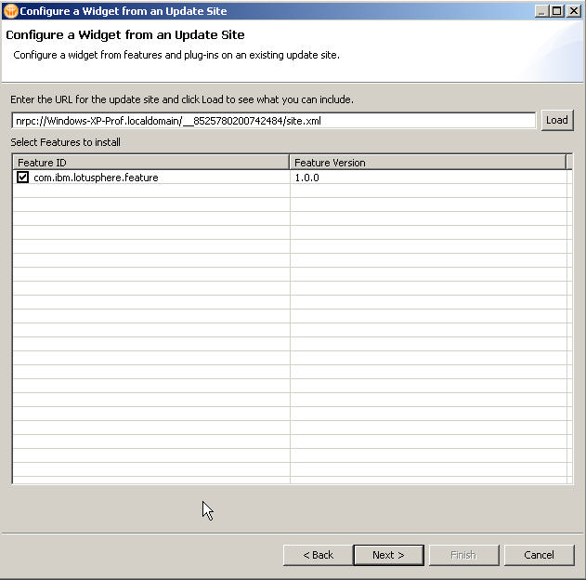

f) Take the defaults on the next page, or enter a description if you wish, and click 'Next' again. This will bring up the Install Manifest for you to review. Click 'Next' again, and the wizard will instruct you to test and publish the widget. Click 'Finish' to create the actual widget in your My Widgets sidebar panel.
This will place the widget in your sidebar, but will also test the widget by making a call out to the Domino server and attempting to install the Feature. After a few moments, you should get a dialog box asking you if you would like to install the Lotusphere Feature 1.0.0. See Figure 6. Select the 'Install this feature' radio button, and click 'OK'. After another few moments, while the Feature installs, it should prompt you to restart your client for the changes to take effect. Please restart.

Figure 6: Install Feature
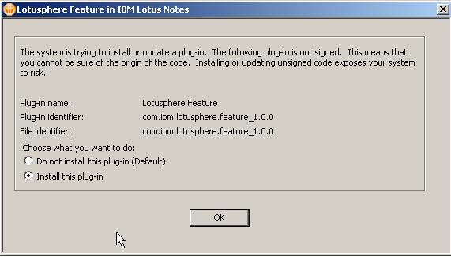

g) Once the client restarts, test the plugin by opening the document in the Lab2 Discussion DB and using the live text recognizers. If successful, we should now be able to Publish the widget to the Widget Catalog for others to use. To do so, right-click on the Widget in your side bar, and select 'Publish to Catalog...'

Extra-credit: Publish all of the items created for this lab to the Widget Catalog (Lead Manager Widget, LS Stock Symbol content type and recognizer, and Lotusphere Feature widget), remove them from the Notes client, and reinstall from the Widget Catalog. Test using the Lab2 Discussion document.

Summary:

In completing this lab, you should now have an understanding of how simple it can be to create an framework to automatically deploy useful features to your entire base of Notes clients. By tweaking some of the steps described here, you can fully manage a wide range of client functionality for some or all of your users. We hope you see how how useful and powerful Domino and Notes are for true 'managed client' environments.

References:
For additional detail, please attend or review the material from Lotusphere 2011 session AD204: Customizing IBM Lotus Symphony and Automating your Enterprise Deployment

IBM Lotus Domino and Notes Information Center: Domino Administrator section “Configuring Widgets and Live Text”

