Welcome to IBM Lotus Notes 8.5.2

A new version of IBM Lotus Notes is coming to your desktop. Take a look at what's in store!

What's new
Here are some great new features:
Open Lotus Connections from the Open list  If your organization has installed the Activities sidebar and configured it to connect to Lotus Connections, you can open Lotus Connections features from the Notes Open list.  Click Open > Lotus Connections, and then select the feature that you want to use. | 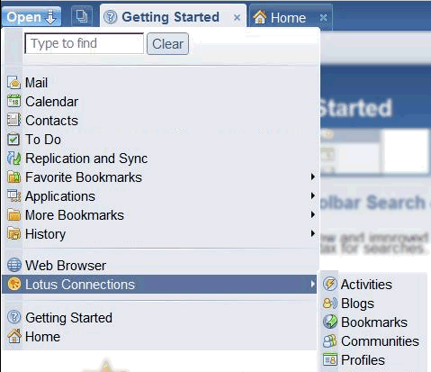
Sort your Inbox by sender's last name (surname)  To list senders by last name in your Inbox, follow these steps:  - Click File > Preferences, and then click Mail.  - On the Basics tab, under Display names in mail in this format select Last First.  Optional: If some senders have last names with prefixes (such as “Van” for "Van Braum") you can list the prefixes under Enter last name prefixes. For additional help, click and hold the "?" icon. | 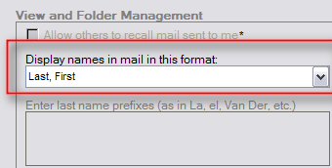
Set a default font for mail  You can now set a default font for the mail you send.  - When composing an email, select text that is in the font you want to use as your default.  - Click Text > Set Current Font as Mail Default.  Your new default font will appear in the next email you compose. It will not effect the current email. | 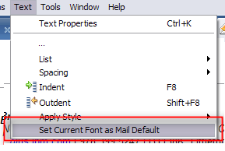

What's changed

Here are some changes from the previous release.
Remove someone from the type-ahead list  When you address an email, calendar entry, or to do item, a list of email address appears as you type. These contacts are the people you email, chat, and meet with most frequently and recently.  If you would like to remove an address from this list, right-click the name in the type-ahead list, and then click Delete. | 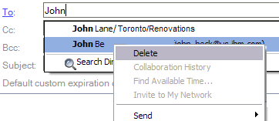
More signature options  When you create a signature to add to emails, you can make it rich text, plain text, or an html or image file.  To add a signature:  - Click File > Preferences, and then click Mail.  - Click the Signature tab.  - Select Automatically append a signature to the bottom of my outgoing mail messages.  - Select the type of signature you would like to use:  - Choose rich text if you want formatting, images, or links.  - Choose plain text if you send messages to people whose email programs read only text.  - Choose an HTML or image file if you want to display your text in a particular format. | 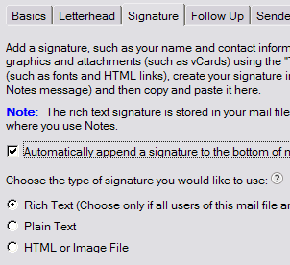
Forward emails from the Trash  You can forward a message from the Trash folder, without having to restore it first. | 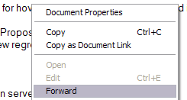
New way to open Activities on the Web

From the Notes sidebar, open the Activities sidebar panel menu, and then select Open in Web Browser.

The Open in Web Browser link is no longer available from the bottom of the Activities panel.

- To add more rows click Table > Row > Insert.
- Choose File > Export to create a PDF of your preview guide.

To view a complete list of new features, see the topic What's New in Lotus Notes 8.5 in the product Help or in the Lotus Notes and Domino Information Center.

Learn more

Resource | Description
Help links and locations | You can view IBM® Lotus Notes® help by clicking Help from the menu, or in the IBM Lotus Domino and Notes Information Center.
Learning Plug-in | Install the Learning Plug-in to access show-me demos, tutorials, product tours, and more, directly from your sidebar. (See the screen image below)
Media Gallery | The Media Gallery provides links to a variety of information including Flash demonstrations, videos, reference cards, Web seminars, product tours, and other materials for learning more about Lotus Notes.
View animated demonstrations on Lotus Notes features in the Lotus Notes and Domino wiki. | See Demonstrations for the Lotus Notes client at http://www-10.lotus.com/ldd/dominowiki.nsf/dx/demonstrations-for-the-lotus-notes-client
Blog | To view and blog about tips for using Lotus Notes, see the Lotus Notes 8.x Tips blog at http://www-10.lotus.com/ldd/notestipsblog.nsf
New Features | To view a complete list of new features, see the topic What's New in Lotus Notes 8.5 in the product Help or in the Lotus Notes and Domino Information Center.

IBM Lotus Notes Learning Plug-in displayed in sidebar

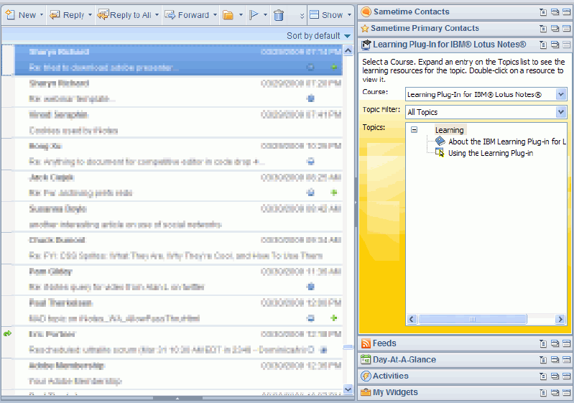

Getting help

Use the following resources to get more assistance:

Resource | Description
Help desk | Put your company-specific instructions here:  Phone number
Internal wiki/blog | Put your company-specific instructions here:  URL
Help links and locations | You can view BM® Lotus Notes® help by clicking Help from the menu, or in the IBM Lotus Domino and Notes Information Center.
Bookmark useful Help topics. | Click Help.  To bookmark: open the topic you want to bookmark, then click .  To view all bookmarks: click .
Submit feedback | Let us know if this guide was helpful to you or provide comments on our Help topics. Click the Submit Feedback button or link in your product Help.

- To add more rows click Table > Row > Insert.
- Choose File > Export to create a PDF of your preview guide.

